Spring Boot – It’s a way to create Spring based Application.

Spring Boot simplifies the process of creating Spring Based Application.

Creating a REST ful web service using Spring-boot is very easy and simple.

<https://spring.io> – Is the official Spring Framework website

<https://spring.io/tools> -- URL to download Spring Tools Suite (Eclipse based IDE) mainly suitable for creating Spring based Applications.

STS.jar – Self Extracting Jar (doble click the jar to extract the contents of it)

Creating Spring Boot Based RESTful Web Service Application

1. Using Spring Initializr (<https://start.spring.io> )
2. Using STS
3. Using Spring Boot CLI (Command Line Interface)

Spring Web – Used to create REST ful Web Service

Web Applications will contain URL and produces HTML response

Web Service will contain URI (End-points) produces XML/JSON response

Dependencies to Create Spring Base REST ful Web Service

1. Spring Web
2. SpringBoot Dev Tools

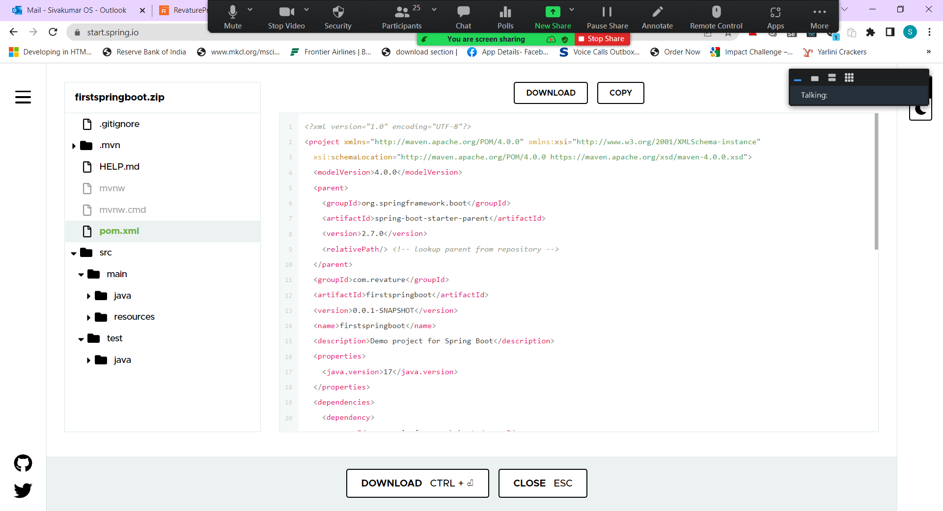

download and install this and it will set all variables for u <https://corretto.aws/downloads/latest/amazon-corretto-8-x64-windows-jdk.msi>

<https://quizlet.com/701023553/week-1-2-concepts->

<https://quizlet.com/703077308/databases-flash-cards/>

<https://quizlet.com/702765098/aws-cloud-computing-databases-flash-cards/>

<https://quizlet.com/702748932/java-collections-flash-cards/>